Social Engineering:
Introduction:
Exploit human element/psychology/trust.
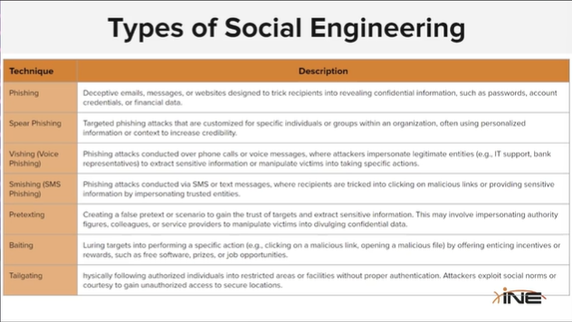

1️⃣ Pretexting
Creating a fake story (pretext) to trick someone into giving information.
👉 Example: Attacker pretends to be IT support and asks for your password.

2️⃣ Baiting
Offering something tempting to trick someone.
👉 Example: Leaving an infected USB labeled “Salary Data” so someone plugs it in.

3️⃣ Tailgating
Following an authorized person to enter a restricted area without permission.
👉 Example: Walking behind an employee into a secure office without using an ID card.
Phishing:
- Planning & reconnaissance
- Message crafting
- Delivery
- Deception & manipulation
- Exploitation

Spear-Phishing:
Specific individuals or groups
- Target selection & research
- Message Tailoring
- Delivery

Pre-Texting:
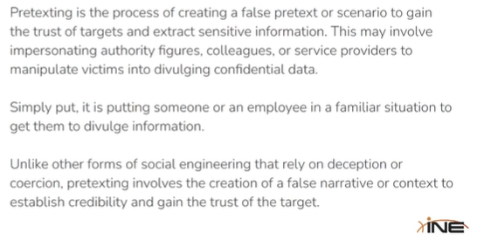
Characteristics of pretexting:
- False pretense.
- Establish Trust
- Manipulating emotions
- Information gathering
- Maintaining consistency

https://github.com/L4bF0x/PhishingPretexts

